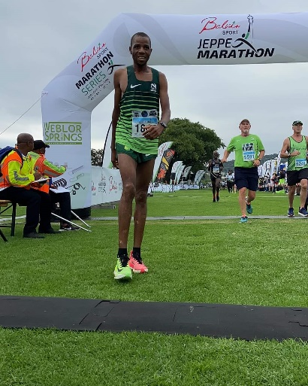

CURRICULUM VITAE: Lucky Mohale

PERSONAL DETAILS
FIRST NAME / SURNAME: Lucky Mohale
DATE OF BIRTH: 21 August 1985
CLUB: Nedbank Running Club
NATIONALITY: South African

PERSONAL BEST TIMES
Distance Year Venue Time
Half Marathon Cape Town (RSA) 2012 1:01:08
Marathon Casablanca (MAR) 2010 2:13:35
10km Paarl (RSA) 2010 28:31
15km Pretoria (RSA) 2015 44:56
25km Pretoria (RSA) 2013 1:18:45

Best Performances 2025
Johnson Crane Hire Half Marathon, 1:07:27, 2nd
Two Oceans 56km, 3:11:27, 3rd

Best Performances 2024
Mpumalanga Marathon, 2:20:25, 2nd
ABSA RYC 10km Tshwane, 29:39, 7th
Foskor Half Marathon, 1:04:29, 1st

Best Performances 2023
Cape Twon Marathon, 2:17:14, 18th

Best Performances 2022
ABSA RYC Durban 10k, Durban, 29:17
Nelson Mandela Bay Half Marathon, Gqeberha, 1:03:43

