Profile of Lungile Gongqa
Date of Birth : 22/02/1979
Club: Phantanne Athletic Club

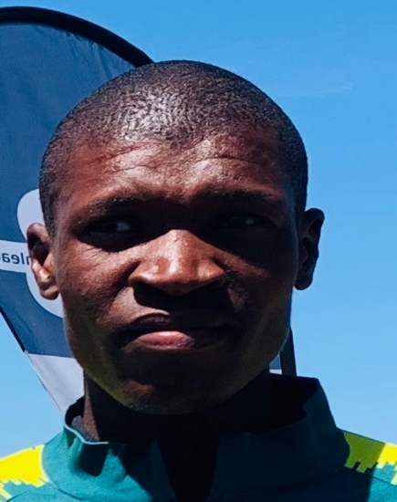

Most recent performances

Year | Event | Distance | Time | Position
2019 | IAU World 50km ( Romania) | 50km | 2:48:26 | 2 nd
2019 | Two Oceans Marathon (SA) | 56km | 3:18:53 | 8 th
2019 | Mandela Marathon | 42.2km | 2:31:30 | 11 th
2019 | South Coast Marathon | 42.2km |  | 1 st
2018 | Heroes Marathon | 42.2km | 2:22:50 | 1 st

