Murray & Roberts Running Club
22 Skeen Boulevard, Bedfordview, 2007, South Africa
Cell: +2776 578 4466
E-mail:dana.coetzee@murrob.com | Web: www.murrob.com
ENGINEERED EXCELLENCE
Profile of Lutendo Mapoto
Date of Birth: 02/11/1988
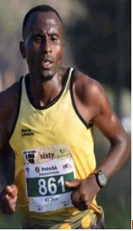
· 2017 Comrades Marathon – 6:00:02
· 2017 KaapseHoop Marathon: Champion – 2:17:56
· 2018 Two Oceans 56km – 3:25:59
· 2019 PetroSA Marathon – 2:25:05
· 2020 Om die Dam 50km: 2nd Position – 2:56:37

