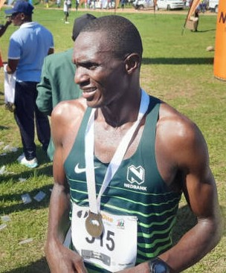

CURRICULUM VITAE: Lyno Muchena

PERSONAL DETAILS
FIRST NAME / SURNAME: Lyno Muchena
DATE OF BIRTH: 2 January 1988
CLUB: Nedbank Running Club
NATIONALITY: Zimbabwe

PERSONAL BEST TIMES
Distance Time Venue Year
Half Marathon 1:07:33 Polokwane (RSA) 2007
Marathon 2:24:12 Kazungula (BOT) 2023

Best Performances 2025
Old Mutual Harare Marathon, 2:26:52,

Best Performances 2024
Two Oceans 56km, 3:14:41, 10th
Comrades Marathon, 5:57:16

Bests Performance 2023
FNB Kazungula Bridge Marathon, Kazungula BOT, 2:24:12, 4th
SA Run4Cancer 48km, 2:42:55

Bests Performance 2022
Two Oceans Marathon (RSA) 56km, 3:26:06

