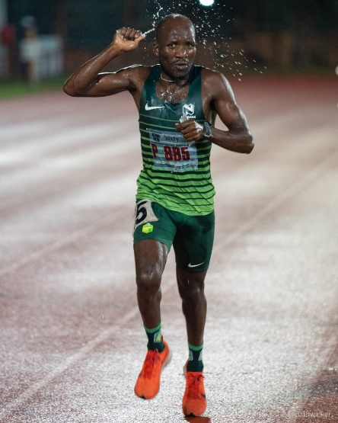

CURRICULUM VITAE: Mziwenkosi Mjaja

PERSONAL DETAILS
FIRST NAME / SURNAME: Mziwenkosi Mjaja
DATE OF BIRTH: 12 June 1989
CLUB: Nedbank Running Club
NATIONALITY: South African
EMAIL: 47987863@mylife.unisa.ac.za
CONTACT: 073 784 2243

Personal best Performances
Event Performance Venue Date
5000m 14:45.29 Durban (RSA) 2021
10,000m 30:04.20 Durban (RSA) 2021
10km 30:35 Durban (RSA) 2022
Marathon 2:30:06 * KwaMashu (RSA) 2015

Performances 2022
ABSA RYC Durban 10k, Durban, 30:35
Best of Best Marathon, 2:40:50

Performances 2021
KZNA Full Day League 5000m, Durban, 14:45, 3rd
KZNA 10000m League, Durban, 30:04, 6th

Performances 2020
Go beyond for a child 15km, 55:00.
Kearsney half marathon 21.1, 1:12:00
DG Panel & Paint challenge 16km, 55:00
Zabalaza marathon 10km, 31:35

