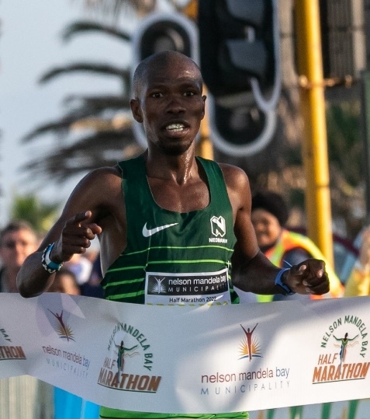

CURRICULUM VITAE: Namakoe Nkhasi

PERSONAL INFORMATION
FIRST NAMES / SURNAME: Namakoe Nkhasi
DATE OF BIRTH: 10 January 1993
CLUB: Nedbank Running Club
NATIONALITY: Lesotho

Personal Bests
Event Result Venue Date
1500m 3:49.72 Port Elizabeth (RSA) 2013
3000m 8:30.86 Potchefstroom (RSA) 2020
5000m 13:21.68 Durban (RSA) 2016
10,000m 28:06.33 Durban (RSA) 2016
10km 27:52 Durban (RSA) 2022
12km 33:43 Cape Town (RSA) 2017
Half Marathon 1:01:01 Port Elizabeth (RSA) 2022
Marathon 2:19:21 Cape Town (RSA) 2021

Best Performances 2025
Biogen Half Marathon, 1:05:56, 1st

Best Performances 2024
Absa Run Your City Joburg 10km, 29:35, 4th
NMB Half Marathon, Pollock Beach, Gqeberha, 1:04:04, 2nd
African Games, University of Ghana Sports Stadium, Accra, Half Marathon, 1:05:58, 4th

Best Performances 2023
Run your City 10km Johannesburg, 29:07, 1st
South African 5km Road Running Championships, Johannesburg, 14:26, 1st
Nelson Mandela Bay Half Marathon, Gqeberha RSA, 1:04:33

Best Performances 2022
Nedbank Running Club Skosana Race, Pretoria 1:05:39, 1st
Two Oceans Half Marathon, 1:04:02, 10th
ABSA Run Your City 10km, Cape Town RSA, 28:24 3rd
ABSA RYC Durban 10km, Durban RSA, 27:52, 2nd
Nelson Mandela Bay Half Marathon, Gqeberha RSA, 1:01:01, 1st

Best Performances 2021
KZNA T&F League 5000m, Kings Park Athletics Stadium, Durban 14:16.59, 2nd
KZNA Ch.5000m, Kings Park Athletics Stadium, Durban 14:06.21, 2nd
ASA/KZNA Olympic Qualifier 5000m, Msunduzi Athletics Stadium, Pietermaritzburg 14:06.45, 4th
KZNA 10000m League, Kings Park Athletics Stadium, Durban 30:05.75, 7th
KZNA Ch.10000m, Kings Park Athletics Stadium, Durban 29:13.65, 4th
Botswana Ch.10000m, National Stadium, Gaborone 29:18.05
Hollywoodbets Durban Summer 10km, Durban 29:04, 6th
Nelson Mandela Bay Half Marathon, Port Elizabeth 1:02:19
Sanlam Cape Town Marathon, Cape Town 2:19:21

