PROFILE OF NATASHA MALAN
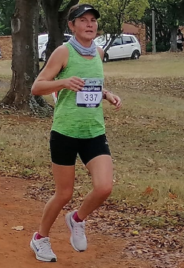

Club | Impala Elite Team
Date of Birth | 1981/12/24
Nationality | South African
YEAR | RACE | PLACE | DISTANCE | TIME
2019 | Los Kop | Loskop | 50km | 3 57
2019 | Secunda half | Secunda | 21.1 Km | 1 27 13
2018 | Comrades | Durban | 89 km | 7 55 12
2018 | Kosmos Secunda | Secunda | 42.2 km | 3 .08.24

