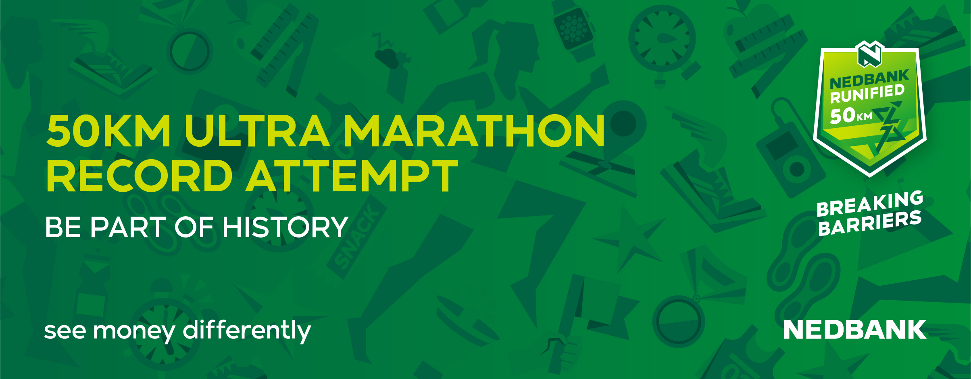
Nedbank Runified course receives accreditation

The course set out for the Nedbank Runified Breaking Barriers 50km has officially been recognized and received International measurement certificate from World Athletics, the governing body of athletics which also incorporate the IAU.

Runners who participated in the recent Nelson Mandela Bay half Marathon which incorporated the South African Championships would have gotten a taste of what is to come, with the course using the same out and back format along the same roads.

With 5 laps of a 10km loop awaiting runners as they attempt to break the existing 50km World records, one cannot ask for a quicker legal course than this. With a 9m above sea level start and finish, there are no hills in sight, with the highest point on the course being 11m above sea level and the lowest point 8m above sea level.

Starting on Marine Drive, runners will head South to the first turning point situated at the 2km mark. Runners will complete this turn and then run North along Marine Drive to pass by the Start/Finish venue 4km into the lap. The lap then continues another 3km North before making a 180 degree turn to return South in Humewood road towards the Start/Finish area when once reached, will mark 10km and one lap completed.

Runners will then complete this 5 times. “We could not ask for a faster course than the one we have on offer to the athletes,” said Nedbank running club national team manager Nick Bester. “We are giving the athletes an opportunity to break barriers on the best possible course that meets legal requirements and also providing pacemakers in the race to assist them.”

The Nedbank Runified Breaking Barriers 50km takes place in the Nelson Mandela Bay Municipality district on 23 May and features a host of National and International athletes attempting to break the existing 50km World records. The race will also feature live TV coverage via Sabc Sport.

