Nobukhosi Tshuma
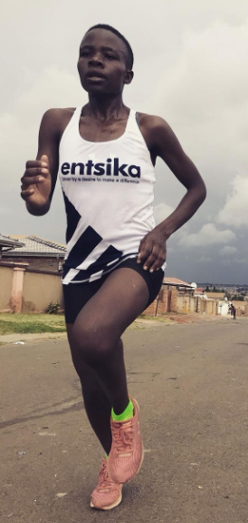
DOB: 1995/08/08
Club : Entsika AC
Coach : Hendrick Ramaala
Personal Bests
Marathon : 2:42 - 2019
21km : 1:18 - 2018
10km : 35:34- 2019
Recent Races | Position | Time | Year
Petro SA Marathon | 1 | 02:43 | 2019
Two Oceans 21km | 7 | 01:18 | 2019
Harry Gwala Marathon | 3 | 02:47 | 2019
Petro SA 21km | 1 | 01:19 | 2018
Spar Ladies 10km | 6 | 36:00 | 2018

