Pharson Morare Magagane

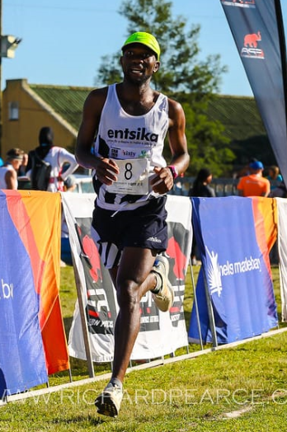

DATE OF BIRTH: 04/04/1986
GENDER: Male
NATIONALITY: South African
CELL NO: 076 582 0445
E MAIL: pharson@webmail.co.za

ACHIEVEMENTS

1. Personal Bests
Event | Result | Venue | Date
800m | 1:49.81 | Donnas (ITA) | 03.07.2011
100m | 2:24.00 | Johannesburg | 19.02.2016
1500m | 3:37.79 | Stellenbosch | 14.03.2009
Mile | 4:00.00 | Cape Town | 10.03.2011
2000m | 5:14.69 | Pretoria | 28.01.2016
3000m | 7:58.38 | Rhede (GER) | 08.07.2011
5000m | 14:14.35 | Cape Town | 16.04.2011
10 000M | 31:30.17 | Pretoria | 25.04.2014
10 km | 29:57 | Stellenbosch | 11.08.2007
Half Marathon | 1:05:39 | Pretoria | 26.04.2014
Marathon | 2:20.46 | Cape Town | 23.09.2018

2. International Events

2006 - World Student Cross Country Champs
2008 - World Student Cross Country Champs
2009 - World Student Games (1500m)
2011 - World Student Games (1500m)

2011-2015 Performance
Achievements | Period/Dates | Tournament or Competition | Time
POSITION 1 | 2011/04/29-30 | USSA CHAMPIONSHIPS 2011 (1500M) | 3:44.95
POSITION 5 | 2011/04/29-30 | USSA CHAMPIONSHIPS 2011 (5000M) | 14:14.35
POSITION 2 | 2011/03/10 | YELLOW PAGES INVITATION SERIES III (MILE) | 4:00.00 (PB)
POSITION 2 | 2011/04/09-10 | YELLOW PAGES SA SENIOR CHAMPS (1500M, Heat 2) | 3:39.65 (SB)
POSITION 3 | 2011/04/09-10 | YELLOW PAGES SA SENIOR CHAMPS (1500M, Final) | 3:40.80
POSITION 3 | 2011/04/16 | YELLOW PAGES INTERPROVINCIAL II | 3:45.02
POSITION 5 | 2011/02/25 | YELLOW PAGES INVITATION SERIES II (1500M) | 3:48.69
POSITION 4 | 2011/07/03 | DONNAS (ITALY) 800M | 1:49.81 (PB)
POSITION 2 | 2011/06/01 | ALBERTVILLE (FRANCE) 3000M | 08:08.49
POSITION 9 | 2011/07/08 | RHEDE (GER) 3000M | 7:58.38 (PB)
POSITION 2 | 2015/04/27 | USSA ATHLETICS CHAMPIONSHIPS | 3:42.93
POSITION 2 | 2015/08/09 | UNIV. OF LIMPOPO RUN FOR EDUCATION | 31:03 (SB)
POSITION 4 | 2015/08/15 | CGA CROSS COUNTRY CHAMPS 4KM | 12:18

- I’ve won bronze medal (3rd position) three times in a row in the 1500m event (2009, 2010, and 2011) at the South African Senior Track and Field Championships.

- I have the distinction of being the first ever athlete to record a legitimate outdoor time of 4:00:00 for a mile in the history of athletics

