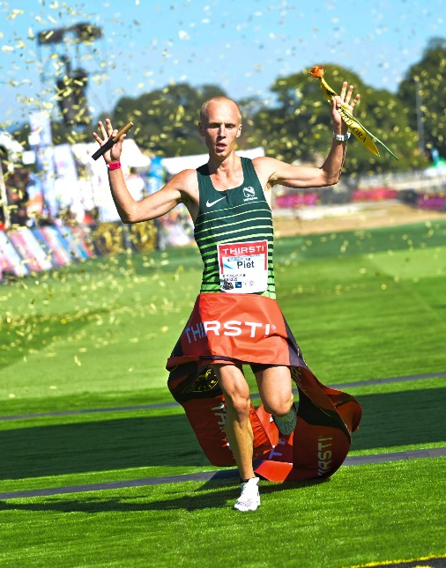
CURRICULUM VITAE: Piet Wiersma

PERSONAL DETAILS
FIRST NAME / SURNAME: Piet Wiersma
DATE OF BIRTH: 20 October 1997
CLUB: Nedbank Running Club
NATIONALITY: Netherlands
GENDER: Male

PERSONAL BEST
Event Result Venue Date
Marathon 2:18:59 Sevilla (ESP) 2023
Comrades 5:14:01 Pietermaritsburg 2023
100 Kilometres 6:18:47 Bernau (GER) 2022

Best Performances 2025
Zurich Maratón Sevilla, Sevilla Marathon, 2:21:19

Best Performances 2024
Comrades Marathon - Up Run (RSA) 86km, 5:25:00, 1st
Milano Marathon, Milano ITA, 2:21:49, 13th

Best Performances 2023
Zurich Maraton de Sevilla, Sevilla ESP, 2:18:59
Comrades Marathon - Down Run (RSA) 87km, 5:14:01, 2nd
di Romagna (ITA) 50km, 3:02:57, 6th

Best Performances 2022
100k World Ch., Bernau GER, 6:18:47, 3rd

Best Performances 2021
45. RUN Winschoten 100 km, Winschoten NED, 6:49:47, 3rd

