Murray & Roberts Running Club
22 Skeen Boulevard, Bedfordview, 2007, South Africa
Cell: +2776 578 4466
E-mail:dana.coetzee@murrob.com | Web: www.murrob.com
ENGINEERED EXCELLENCE
Profile of Reinier Grobler
Date of Birth: 13/03/1983
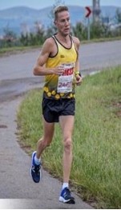
· 2017 Om die Dam 50km – 3:08
· 2017 Comrades Marathon – 6:10
· 2017 Wing for Life World Run – SA Champion – 63,07km
· 2018 Two Oceans 56km – 3:34
· 2018 Comrades Marathon – 6:12
· 2018 Wing for Life World Run – Switzerland: 2nd Position – 68.6km
· 2019 Comrades Marathon – 6:14
· 2019 Uniwisp 5-in-1, 50km – Nelspruit: 2nd Position – 3:02
· 2020 Om die Dam 50km:10th Position – 3:05
· 2021 African X: 3rd Position – Men Open

