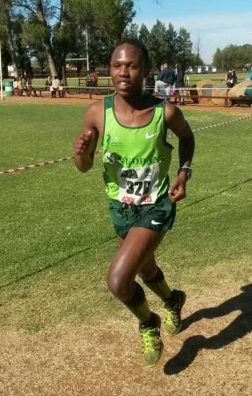

CURRICULUM VITAE: Rueben Mosiane

PERSONAL DETAILS
NAME & SURNAME: Rueben Mosiane
DATE OF BIRTH: 12 April 1997
CLUB: Nedbank Running Club
GENDER: Male
NATIONALITY: South African

Personal Best Times
Event Result Venue Date
Marathon 2:23:11 Klerksdorp (RSA) 2023

Best Performances 2025
Balwin Sport Pretoria Marathon, 2:26:50, 1st

Best Performances 2024
Intercare Classic Half Marathon, 1:09:00, 3rd
Tshwane North Ultra 50km, 2:56:53, 1st
SA Run4Cancer Ultra Marathon 48km, 2:52:29, 2nd

Best Performances 2023
Klerksdorp Marathon, 2:23:11, 1st

