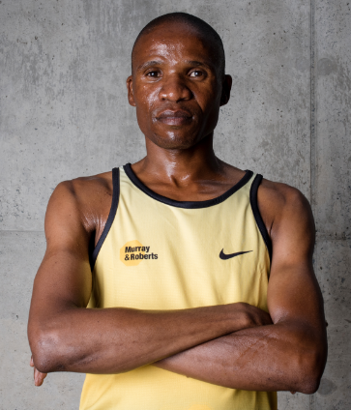

Rufus
Date of Birth: 17/031980
- 3 Comrades Gold medals (2013, 2014 &2016)
- 2019 Comrades Marathon: 13th - 5:55:09
- 2018 Two Oceans 56km: 13th -3:20
- 2016 Comrades Marathon: 5th – 5:35:40
- 2014 Comrades Marathon: 5th – 5:35:30
- 2013 Comrades Marathon:9th – 5:51:52
- 2011 Kaapse Hoop Marathon: 2:19 (PB)

