Profile of SILINDILE CHILI
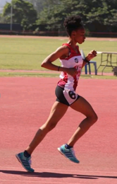

Running is my past, present and future. So much I still wish to achieve. I am a marathon and middle distance runner with a potential for ultra. I am currently in Pretoria as I was selected to represent KZN on the 10 000m SA Senior Championship.

Below please find my achievements:

- 2018 Delliot Marathon Champion (02:50)
- 2018 OR Tambo Marathon: 3rd position (03:04)
- 2018 Petrosa Marathon: 02:57
- 2021: Umthatha Half Marathon Champion

