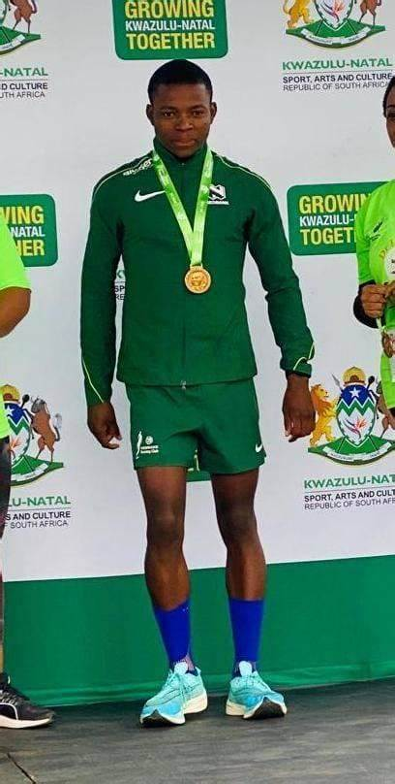

CURRICULUM VITAE: Sinethemba Tshangase

PERSONAL DETAILS
FIRST NAME / SURNAME: Sinethemba Tshangase
DATE OF BIRTH: 12 May 1998
CLUB: Nedbank Running Club
NATIONALITY: South Africa

PERSONAL BEST
Event Result Location Date
Marathon 2025 2:20:25 Weatern Cape (RSA) 2025
Half Marathon 1:04:41 Gqeberha (RSA) 2023
10km 29:48 Gqeberha (RSA) 2021
5000 Metres 14:39.49 Durban (RSA) 2021

Personal Performances 2025
Balwin Sport Peninsula Marathon, 2:20:25

Personal Performances 2023
Nelson Mandela Bay Half Marathon, Gqeberha, 1:04:41

Personal Performances 2022
Soweto Marathon, 2:34:37
ABSA RYC Durban 10k, 29:50
Threshhold Hillcrest Half Marathon, Durban, 1:07:02, 1st
ABSA Run Your City 10km, Cape Town, 30:59

