Murray & Roberts Running Club
22 Skeen Boulevard, Bedfordview, 2007, South Africa
Cell: +2776 578 4466
E-mail:dana.coetzee@murrob.com | Web: www.murrob.com
ENGINEERED EXCELLENCE
Profile of Sithembiso Mqhele
Date of Birth: 18/021991
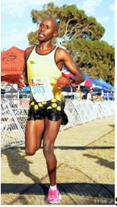
· 2019 PPC Riebeeck Berg Marathon: Champion – 2:40:24
· 2019 Sanlam Cape Town Marathon: Sub 2:30 – 2:29:34
· 2020 Cape Peninsula Marathon: 2nd Position – 2:22:07
· 2020 Sanlam Cape Town Invitational Marathon: 2:25:13 (Cape Town)

