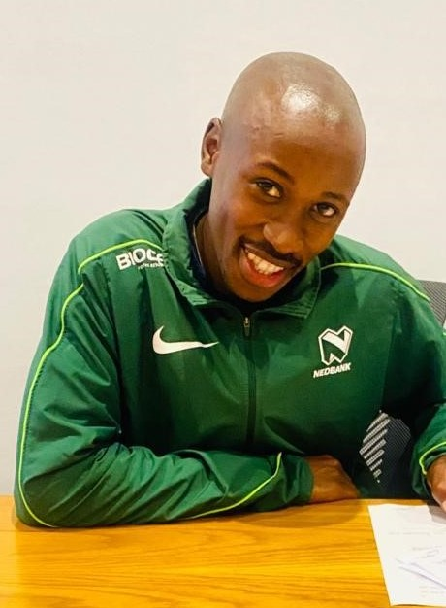

CURRICULUM VITAE: Sithembiso Mqhele

PERSONAL DETAILS
FIRST NAME / SURNAME: Sithembiso Mqhele
DATE OF BIRTH: 18 February 1991
CLUB: Nedbank Running Club
NATIONALITY: South African

PERSONAL BEST TIMES
Distance Time Venue Year
5000m 15:19.17 Stellenbosch (RSA) 2021
10km 31:13 Cape Town (RSA) 2022
12km 39:35 Cape Town (RSA) 2021
Marathon 2:18:33 Cape Town (RSA) 2021
50km 2:51:25 Eastern Province (RSA) 2024
Comrades 5:57:44 Durban (RSA) 2024

Best Performances 2024
Runified 50km, 2:51:25, 4th
Comrades Marathon - Up Run (RSA) 86km, 5:57:44
1 City Marathon, 2:21:20, 4th

Best Performances 2023
Durban International Marathon, Durban, RSA, 2:25:34
Bay to Bay 30km, 1:36:34, 2nd
Two Oceans 56km, 3:14, 9th

Best Performances 2022
ABSA Run Your City 10km, Cape Town, RSA, 31:13
OUTsurance Gun Run, Cape Town, RSA, 1:09:18
Cape Peninsula Marathon, Cape Town, RSA, 2:22:00, 1st
Two Oceans 56km, 3:14, 7th

Best Performances 2021
WPA Track & Field Championship 5000m, Cape Town, RSA, 15:25.11, 9th
Invitational Middle Distance Track Series 5000m, Stellenbosch, RSA, 15:19.17, 2nd
Cape Town 12K CITYRUN, Cape Town, RSA, 39:35
Sanlam Cape Town Marathon, RSA, 2:18:33

