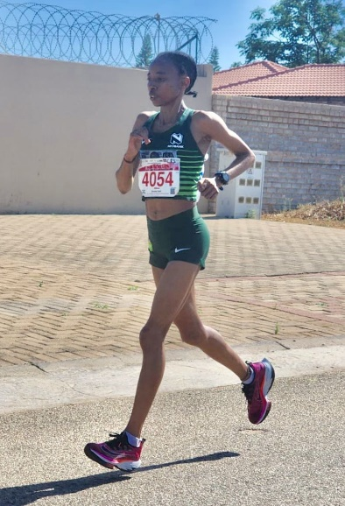

CURRICULUM VITAE: Slindile Chili

PERSONAL INFORMATION
FIRST NAMES / SURNAME: Slindile Chili
COUNTRY: South Africa
DATE OF BIRTH: 1994/07/03
CLUB: Nedbank Running Club

Personal Best Perfomnces
Discipline Performance Venue Date
10,000m 38:44.21 Stellenbosch (RSA) 2015
10km 37:05 Durban (RSA) 2014
Half Marathon 1:22:28 Mount Edgecombe (RSA) 2014
Marathon 2:57:21 Mossel Bay (RSA) 2019

Best Performances 2025
Prince Mangosuthu Ultra Marathon 52km, 3:51:26, 4th

Best Performances 2024
Runified 50k, 3:32:13, 2nd
Absa Run Your City Joburg 10km, Johannesburg, 38:38
Tshwane North Ultra (RSA) 50km, 4:04:31, 5th
Comrades Marathon - Up Run (RSA), 7:57:34

Best Performances 2023
Brooklyn Road Race Half Marathon, 1:30:10, 7th
SA Run 4 Cancer 48km Ultra Marathon, 3:26:01, 3rd

Best Performances 2022
Durban City Marathon, Durban, RSA, 3:00:56, 1st

Best Performances 2021
KZNA 10000m League, Durban, RSA, 39:53.34, 4th
KZNA Ch., Durban, RSA, 39:41.52, 4th
Prince Mangosuthu Ultra Marathon, 4:08:46, 4th

Best Performances 2019
Petro SA Marathon, Mossel Bay, RSA, 2:57:21, 6th

