Profile of TK Moshwetsi
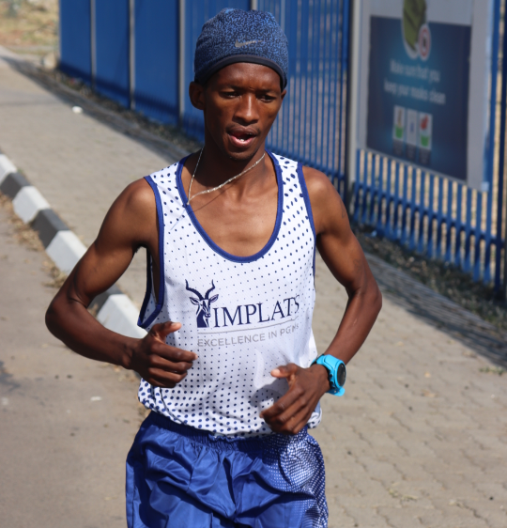
Date of Birth |  |  | 1988-06-26
Nationality |  |  | South African
YEAR | RACE | PLACE |  | DISTANCE | TIME
2020 | Sanlam | Potchefstroom |  | 42.2 Km | 2:17:04
2020 | Om Die dam | Harties |  | 21.1 Km | 69.12
2019 | Sanlam | Cape Town |  | 42.2 Km | 2.16.12

