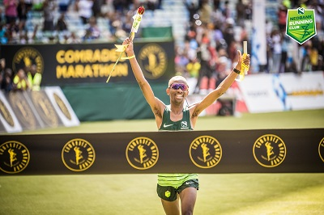

CURRICULUM VITAE: Tete Morena Dijana

PERSONAL DETAILS
FIRST NAME / SURNAME: Tete Dijana
DATE OF BIRTH: 1988
CLUB: Nedbank Running Club
NATIONALITY: South African

PERSONAL BEST TIMES
Distance Time Venue Year
5000 Metres 14:48.23 Durban (RSA) 2011
Half Marathon 1:05:46 Port Elizabeth (RSA) 2021
50km 2:39:04 Port Elizabeth (RSA) 2023
Marathon 2:13:24 Cape Town (RSA) 2023
Comrades 5:13:58 Durban (RSA) 2023

Best Performances 2025
TrackN4 Elands Marathon, 2:18:18, 1st

Best Performances 2024
Comrades Marathon (Up Run), 5:42:15, 14th
Soweto Marathon, 2:22:32, 9th

Best Performances 2023
Nedbank Runified, 50km, 2:39:04, 1st
Comrades Marathon (Down Run), 5:13:58, 1st
Phobians 15km, 50:34, 3rd
Brooklyn 32km, 1:54:23, 4th
Cape Town Marathon, 2:13:24, 10th

Best Performances 2022
ACNW Open T&F Meeting 5000m, Potchefstroom, 15:01.60, 3rd
Nedbank Runified 50km 2:44:09, 2nd
Comrades Marathon (Down Run) 5:30:35, 1st

Best Performances 2021
Nelson Mandela Bay Half Marathon, Port Elizabeth RSA, 1:05:46

Best Performances 2019
Comrades Marathon (Up Run) 6:25:03

