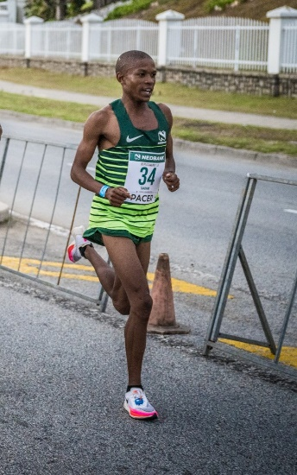

CURRICULUM VITAE: Thabang Mosiako

PERSONAL DETAILS
NAME & SURNAME: Thabang Mosiako
DATE OF BIRTH: 23 February 1995
CLUB: Nedbank Running Club
GENDER: Male
NATIONALITY: South African

Personal Best Times
Event Result Venue Date
800m 1:55.40 Potchefstroom (RSA) 2016
1500m 3:50.44 Potchefstroom (RSA) 2019
3000m 8:05.83 Potchefstroom (RSA) 2018
5000m 13:58.64 Cape Town (RSA) 2022
10000m 29:00.38 Durban (RSA) 2017
10km 27:45 Lille (FRA) 2023
12km 34:38 Cape Town (RSA) 2018
15km 44:23 Le Puy-en-Velay (FRA) 2024
Half Marathon 59:52 Riga (LAT) 2023
Marathon 2:09:14 Abu Dhabi (UAE) 2024

Best Performances 2024
Absa Run Your City Gqeberha 10km, Gqeberha RSA, 28:30, 4th
du Puy en Velay 15 Km, Le Puy-en-Velay FRA, 44:23, 3rd
EDP Lisbon Half Marathon, Lisboa - Elite Event POR, 1:01:42, 6th
Two Oceans Half Marathon, 1:04:40, 1st
ADNOC Abu Dhabi Marathon, Abu Dhabi, 2:09:14, 8th
Absa Run Your City Tshwane 10km, 29:50, 10th
Absa Run Your City Durban 10km, 27:54, 3rd

Best Performances 2023
Urban Trail de Lille 10km, FRA, 27:45, 6th
Nelson Mandela Bay Half Marathon, RSA, 1:00:29, 1st
World Athletics Road Running Championships, LAT, 59:52, 6th
NMBM Kariega Human Race Half Marathon, 1:03:36, 1st
ABSA run your city 10km, 27:52, 3rd

Best Performances 2022
ACNW Ch., 5000m, Potchefstroom RSA, 14:22.02, 1st
South African Championships, 5000m, Cape Town RSA, 13:58.64, 5th
ABSA Run Your City 10km, Cape Town RSA, 28:43, 9th
ABSA RYC Durban 10k, Durban RSA, 28:26, 9th
ABSA Run Your City Joburg 10km, Johannesburg RSA, 31:14, 12th
10km de Figuig, Figuig MAR, 29:28, 3rd
Totalsports Two Oceans Half Marathon, Cape Town RSA, 1:03:58, 7th
Nelson Mandela Bay Half Marathon, Gqeberha RSA, 1:03:36
Semi Marathon International de la Ville de Béjaia, Béjaïa ALG, 1:03:51, 1st

