Profile of Thandokwakhe Ngcobo
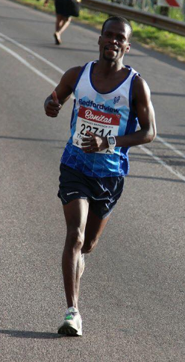
DOB:1980/10/29
Club : Entsika AC
Coach : Hendrick Ramaala

Personal Bests:
2002 RAC 5km: 16:33
2002 Soweto 15km :47:49
2013 City to City 50km: 3:08:20
2014 Allan Rob 32km: 1:47:46
2014 Old Ed's 21km : 1:11:34
2014 RAC 10km: 33:27
2018 Comrades Marathon: 5:53:06
2018 Cape Town Marathon: 2:24:31
Marathon Races
2018 Edenvale Mararhon 2:31:31
2018 Cape Town Marathon 2:24:31
2019 Township to Township Marathon 2:34:31
2020 NMB Marathon : 2:26:02
Comrades Marathon
Comrades Marathon - 6:30:58
Comrades Marathon - 5:53:06

