Why you have heel pain from running
At heel strike, heel pain occurs because plantar pressure and maximum forces are exceedingly high at the heel. In most cases, plantar fasciitis is usually the main cause of the heel pain, but when conservative interventions fail, experts believe compression of the calcaneal nerve could be the culprit.
In support of this, Henricson and Westlin (1984) investigated the effects of surgical decompression of the calcaneal nerve(s) on chronic heel pain in heel strike runners who competed at the top international or national level.
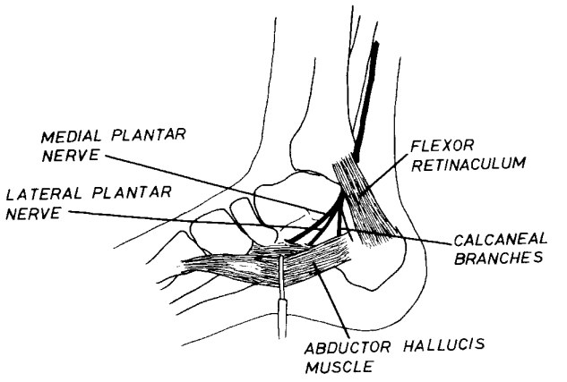Illustration from the study showing the location of the calcaneal nerve
Pre-op, all runners complained of intense heel pain at heel strike during running and were incapable of training or competing because of the severity of the pain.
For the nerve decompression operation, calcaneal nerve branch(es) was dissected distally.
Post-op, most of the runners returned to normal without recurring heel pain.
Because compression of a calcaneal nerve branch causes chronic heel pain in heel strike runners, the researchers strongly recommended that surgical decompression of the entrapped nerve is the most sensible solution if heel pain responds poorly to conservative interventions. But really, who wants to get surgery? A much less invasive approach would be to avoid heel strike altogether when running, and land more forefooted.

How forefoot running helps
Selective pressures reduce heel pressure via forefoot running. What I mean by this is nature needed a way to keep early humans from dying out due to running-related injuries –if they couldn’t run, they couldn’t catch food. Thus, our ancestors avoided high heel pressures via forefoot running to maintain the physical activity needed to obtain the resources to live –to run after food and protect themselves. They ran barefoot or in minimalist footwear which facilitated desirable footfalls that played a key role in both preventing and fostering resilience against common injuries suffered by runners today.
Runners are predisposed to injuries, especially plantar nerve compression, when we deviate away from the biomechanics and plantar conditions our ancestors needed for survival –those necessary for running barefoot or pure minimalist without injury.

