Murray & Roberts Running Club
22 Skeen Boulevard, Bedfordview, 2007, South Africa
Cell: +2776 578 4466
E-mail:dana.coetzee@murrob.com | Web: www.murrob.com
ENGINEERED EXCELLENCE
Profile of Yolande Maclean
Date of Birth: 10/03/1978
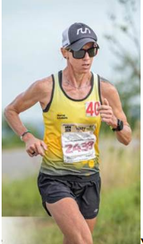
- Eight times Comrades Marathon Gold Medallist: Best Time – 6:29:47
- Several Gold Medals at the Two Oceans 56km Marathon
- Several Gold Medals at the Loskop 50km Marathon
- 2018 Wings for Life World Run: 48km – 2nd Women in South Africa
- 2019 Represented South Africa @ World 50km Championships in Romania
- 2020 Sanlam Cape Town Invitational Marathon: 2nd Position (Pretoria) – 2:57:30
- Represented CGA province several times in the marathon
- Win several road and trail races Nationwide

